H.T No
Regulations:
A22

Sreenidhi Institute of Science and Technology
(An Autonomous Institution)
Code No: 9AC42 Date: 18-Feb-2025 (FN)

B.Tech I-Year II- Semester External Examination, February-2025 (Supplementary)
ELECTRICAL CIRCUITS & NETWORK ANALYSIS (ECE and ECM)

Time: 3 Hours Max.Marks:60

Note: a) No additional answer sheets will be provided.
b) All sub-parts of a question must be answered at one place only, otherwise it will not be valued.
c) Missing data can be assumed suitably.
Bloom's Cognitive Levels of Learning (BCLL)

Remember | L1 | Apply | L3 | Evaluate | L5
Understand | L2 | Analyze | L4 | Create | L6

Part - A Max.Marks: 6x2=12

Answer all QUESTIONS, EACH QUESTION CARRIES 2 MARKS.

 |  | BCLL | CO(s) | Marks
1 | Define KVL,KCL | L1 | CO1 | [2M]
2 | Generalize the RMS and Form factor of a sinusoidal waveform. | L2 | CO2 | [2M]
3 | Explain the dot convention | L6 | CO3 | [2M]
4 | Examine the limitations of maximum power transfer theorem? | L3 | CO4 | [2M]
5 | Develop the condition of Symmetry for Y- Parameters? | L4 | CO5 | [2M]
6 | Define time constant of RC circuit | L1 | CO6 | [2M]

Part – B Max.Marks: 6x8=48
ANSWER ALL QUESTIONS. EACH QUESTION CARRIES 8 MARKS.

 |  | BCLL | CO(s) | Marks
7. | Find the current flowing through 20Ω resistor shown in the figure  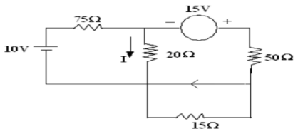 | L5 | CO1 | [8M]
 | OR
8 | Find the voltage across R, in the network shown in below Figure 2 by mesh analysis  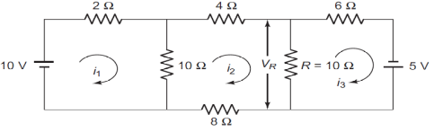 | L2 | CO1 | [8M]
9. | A voltage of (100+j60) volts drives a current of (4-j5) Amps through a series R- L-C circuit. Determine (i) The complex expression for impedance (ii) Power consumed (iii) Power factor (iv)Draw the phasor diagram | L4 | CO2 | [8M]
 | OR
10 | Explain the term band width and Q factor for a series circuit. Derive expressions for the same. | L5 | CO2 | [8M]
11 | a) Examine the expression for co-efficient of coupling?  b) Two similar coil are connected in series gave a total inductance of 600mH. When one of the coil is reversed, the total inductance is 300mH. Find the mutual inductance and coefficient of coupling? | L3 | CO3 | [8M]
 | OR
12 | Explain about parallel connection of coupled inductors and derive the equivalent inductance for parallel opposing? | L1 | CO3 | [8M]
13 | Explain Thevenin’s theorem and to find the current in 3ohm resistor in below  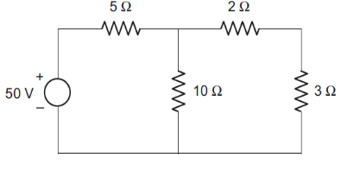 | L5 | CO4 | [8M]
 | OR
14 | Identify the maximum power transferred to load resistance RL in the circuit below figure  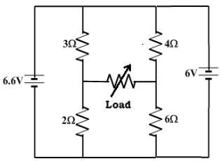 | L4 | CO4 | [8M]
15 | Solve the Y-parameters for the circuit shown in figure  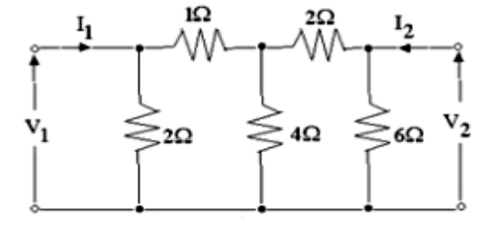 | L2 | CO5 | [8M]
 | OR
16 | The Z-parameters of a two- port network are Z11=15Ω, Z12=Z21=6Ω and Z22=24Ω. Determine ABCD parameters | L3 | CO5 | [8M]
17 | Show the expression for response in a series R-L circuit when it is excited by sinusoidal source | L6 | CO6 | [8M]
 | OR
18 | A series R-C circuit shown in fig. consist R=10ohm and C=0.1F. initially switch K is kept open for very long time. At t=0 it is closed. Find expression for Vr(t) , Vc(t) and Ic(t) against time.  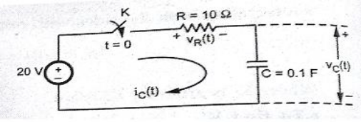 | L2 | CO6 | [8M]

-- 00 -- 00 –

